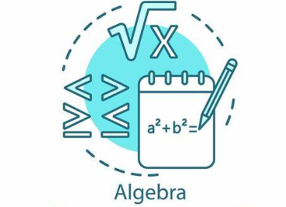**WEEK AT A GLANCE**

**August 12th to August 16th**

**MONDAY:** Edgenuity Coursework

1. Login into Edgenuity
2. Start Lessons
3. Quizzes and Tests must be done in class and approved before taken

**TUESDAY:** Edgenuity Coursework

1. Login into Edgenuity
2. Start Lessons
3. Quizzes and Tests must be done in class and approved before taken

**WEDNESDAY:** Edgenuity Coursework

1. Login into Edgenuity
2. Start Lessons
3. Quizzes and Tests must be done in class and approved before taken

**THURSDAY:** Edgenuity Coursework

1. Login into Edgenuity
2. Start Lessons
3. Quizzes and Tests must be done in class and approved before taken

**FRIDAY:**

Edgenuity Coursework

1. Login into Edgenuity
2. Start Lessons
3. Quizzes and Tests must be done in class and approved before taken